**R Code for Examples in the book**

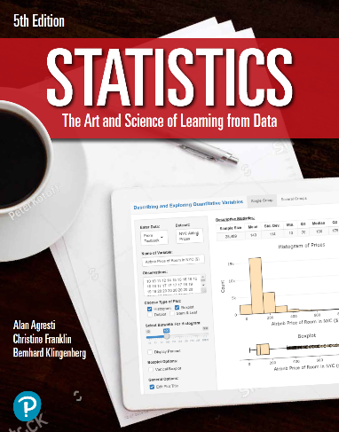

***“Statistics: The Art and Science of Learning from Data”***

**by Agresti, Franklin and Klingenberg, 5th edition**

**Chapter 12**

**Example 5: Strength and Bench Presses – Inference About the Slope**

## Reading in data

athletes <- read.csv(file='https://raw.githubusercontent.com/artofstat/data/master/Chapter12/highschool_female_athletes.csv')

## Fitting regression model

linReg <- lm(maxBP..lbs. ~ BP60, data = athletes)

## To view a summary of the regression model which includes the t-statistic and corresponding p-value for the null hypothesis that the slope for BP60 = 0

summary(linReg)

##   
## Call:  
## lm(formula = maxBP..lbs. ~ BP60, data = data)  
##   
## Residuals:  
## Min 1Q Median 3Q Max   
## -17.9205 -5.9027 -0.7237 5.4989 19.0973   
##   
## Coefficients:  
## Estimate Std. Error t value Pr(>|t|)   
## (Intercept) 63.5369 1.9565 32.475 < 2e-16 ***  
## BP60 1.4911 0.1497 9.958 6.48e-14 ***  
## ---  
## Signif. codes: 0 '***' 0.001 '**' 0.01 '*' 0.05 '.' 0.1 ' ' 1  
##   
## Residual standard error: 8.003 on 55 degrees of freedom  
## Multiple R-squared: 0.6432, Adjusted R-squared: 0.6368   
## F-statistic: 99.17 on 1 and 55 DF, p-value: 6.481e-14